REPORT

CUSTOMER'S REF NO.:
ALS THAILAND REF NO.: | ATT/ELP/14/4395-G
OUR REF NO.: | ATS/ELT/0278/15
DATE: | 01 April 2015
COMPANY: | NMB-Minebea Thai Ltd.
 | 1 Moo 7, Phaholyothin Road, Km.51 Tambon Chiang Rak Noi,
 | Amphur Bang Pa in Ayutthaya Province 13180, Thailand
DATE SAMPLE RECEIVED: | 19 March 2015
DATE ANALYZED: | 25 March 2015
DATE TEST COMPLETED: | 30 March 2015

SAMPLE DESCRIPTION: | One lot of sample was received with references:
Description: MBA Lightning Bug3D (ww#32) date code 4325
Serial no.: 1YNZY, 1YL14 Lot QA: LN2A520007
 | Model: Lightning Bug 3D
 | Surface Area: Hub: 9.25 cm2 , Base: 115.49 cm2
METHOD/PROCEDURE:
Analysis | Procedure No | Sample Size | Extraction Medium | Extraction Vol (ml)
GCMS Extractable | D0000180658 Rev.K | 1 piece | n-Hexane  (HPLC grade) | Motor Hub 10 mL,  Motor Base 60 mL
RESULTS :
The Specification is based on Seagate's Doc 20800010-160 Rev.BE for Spindle Motor / Motor Base Assembly (2.5")
Motor Oil Contamination | Maximum Allowable Amount  (ng/cm2) | Results  (ng/cm2)
Motor Oil - Base | 0.6 | 0.14
Motor Oil - Hub | 10 | Not Detected
Motor Hub | Maximum Allowable Amount  (ng/part) | Results  (ng/part)
Repeated Hydrocarbon  (C20-C40 Alkanes) | NA | Not Detected
 | Maximum Allowable Amount  (ng/cm2) | Results  (ng/cm2)
Total Organic Compound (TOC) | 50 | 14.97
Compounds with RT ≤ DOP | NA | 14.97
Compounds with RT > DOP | NA | 0.00
Motor Base | Maximum Allowable Amount  (ng/part) | Results  (ng/part)
Repeated Hydrocarbon  (C20-C40 Alkanes) | NA | Not Detected
 | Maximum Allowable Amount  (ng/cm2) | Results  (ng/cm2)
Total Organic Compound (TOC) | 50 | 19.58
Compounds with RT ≤ DOP | NA | 11.62
Compounds with RT > DOP | NA | 7.96

ALS THAILAND REF NO.: | ATT/ELP/14/4395-G
OUR REF NO.: | ATS/ELT/0278/15
DATE: | 01 April 2015
COMPANY: | NMB-Minebea Thai Ltd.

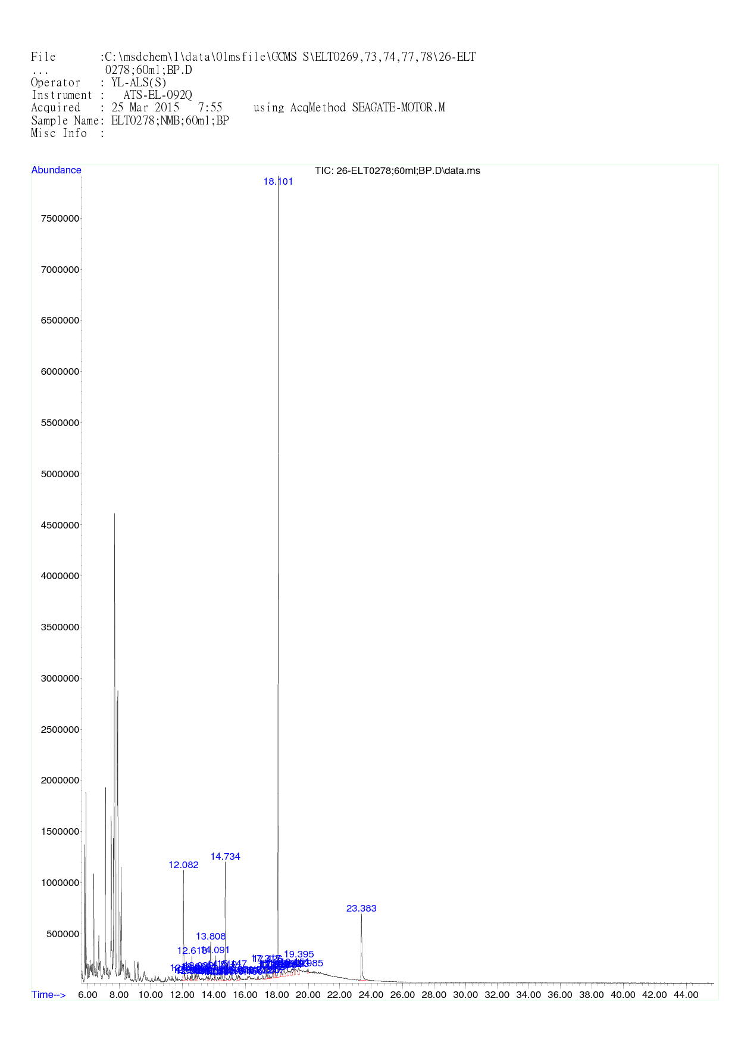

ALS THAILAND REF NO.: | ATT/ELP/14/4395-G
OUR REF NO.: | ATS/ELT/0278/15
DATE: | 01 April 2015
COMPANY: | NMB-Minebea Thai Ltd.
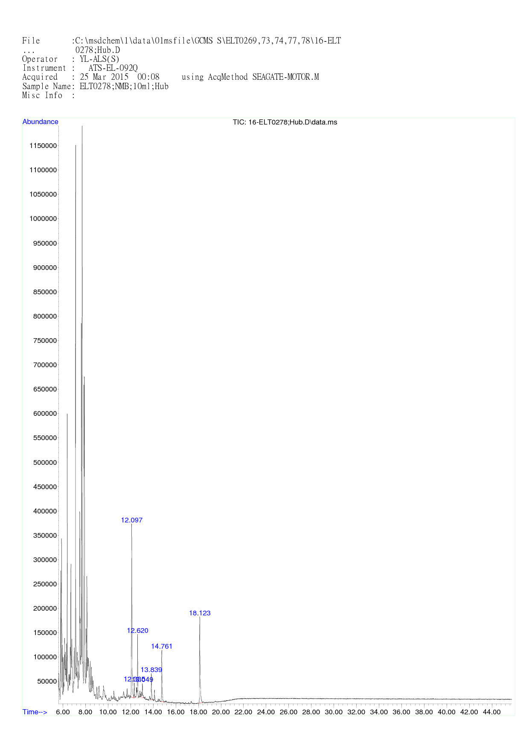
Note: This report was performed test by ALS Singapore.
Remark: Minimum Detection Limit is 0.954 ng/part.
Minimum RHC Detection Limit of Base is 0.008ng/cm2
Minimum RHC Detection Limit of Hub is 0.103ng/cm2
ALS Testing Services
(Thailand) Co.,Ltd.
-----------------------------------
Warunee Maneesuwan
M.Sc, B.Sc, Laboratory Manager

